EMBARGOED UNTIL SEPT. 29, 2022 at 1:00 PM EST

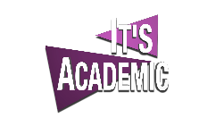

WETA AND ALTMAN PRODUCTIONS
ANNOUNCE WETA IS NEW BROADCAST HOME OF
IT’S ACADEMIC

Longest-Running High School Quiz Series Returns for 62nd Season
Exclusively on WETA

ARLINGTON, VA — September 29, 2022 — WETA President and Chief Executive Officer Sharon Percy Rockefeller and It’s Academic Executive Producer Susan Altman announced today that WETA, the leading public media station in the nation’s capital, will be the new broadcast home of It’s Academic, the longest-running high school TV quiz show in the world. The weekly competition series, now in its 62nd season, will broadcast exclusively on WETA and will debut Saturday, October 29 at 10:00 a.m. and repeat at 7:00 p.m. on WETA PBS and WETA Metro. The first episode will feature teams from Herndon High School in Herndon, Washington-Liberty High School in Arlington, and W.T. Woodson High School in Fairfax.
“WETA is delighted to welcome It’s Academic to our air,” shared Rockefeller. “Celebrating lifelong learning is at the very core of our mission of service to the community of Greater Washington, and this treasured program is a wonderful addition to our engaging educational offerings. The talented students on the show inspire us all as they demonstrate their love of learning, teamwork, and friendly competition. It’s Academic is a perfect fit for WETA."
Altman noted, “Over the years, It’s Academic has worked to encourage community support for education and intellectual achievement. WETA has always shared these goals and we are delighted to partner with them in providing a platform to show our students, our schools and our teachers at their best.”
The Emmy Award-winning program, launched in 1961, spotlights the academic achievements of students from local schools and was formerly broadcast on NBC affiliate WRC-TV. More than 80 high schools from the Washington, D.C. region will participate during the upcoming season. WTOP Anchor and Emmy Award-winning journalist Hillary Howard will host the program, as she has done since 2011.
"It's Academic and WETA are a natural fit,” said Howard. “They both were born in 1961. They both believed then, as now, that knowledge unlocks opportunity. For 61 years, they each invested in exceptional programming to educate our region’s kids and promote love of learning. I can't wait to join the WETA family! It's thrilling to help merge our legacies – and together – build a new one. There is no better partner.”
It’s Academic is produced by Altman Productions, Inc. in cooperation with DMR Productions, LLC. Executive producers for the program are Susan Altman and David M. Rubenstein. Major funding for It’s Academic is provided by MITRE.
“It’s Academic is a Washington institution. I am pleased to join the It’s Academic team as executive producer and to continue to help the show educate and inspire students,” said Rubenstein. “I remember watching the show when I was growing up, and I realized how I had better study harder if I was going to get anywhere. We need engaged citizens, so I encourage students to read, learn, get involved and make a difference.”
“It’s Academic and WETA share our commitment to motivate students to discover, create, and lead in their communities,” said Jason Providakes, president and CEO of MITRE, a not-for-profit research and development company working in the public interest. “We are pleased to continue our support of this iconic quiz show and foster young talent in STEM and other disciplines.”
“WETA is committed to bringing Washington area viewers the best local programming and It’s Academic is one of the most iconic and enduring programs on local TV,” said WETA Senior Vice President and General Manager Miguel Monteverde. “We’re honored to be the new home for this beloved local show.”
Episodes initially broadcast on Saturdays at 10:00 a.m. and 7:00 p.m. on WETA PBS and WETA Metro. Each episode will encore the following Monday at 3:00 p.m. on WETA PBS and 7:00 p.m. on WETA Metro. Episodes will also be available to stream on the PBS Video App and at weta.org. For more information, visit weta.org/itsacademic.
ABOUT THE PARTNERS
About IT’S ACADEMIC – WASHINGTON, DC
The Guinness Book of World Records has recognized It's Academic as the world’s longest-running high school TV quiz show. Founded in 1961 by Sophie Altman, It’s Academic has for over 60 years featured thousands of students from high schools throughout the Washington, D.C. region. It’s Academic provides a showcase for high school students, encourages intellectual curiosity and promotes a lifelong journey of learning and accomplishments.

About David M. Rubenstein
David M. Rubenstein is Co-Founder and Co-Chairman of The Carlyle Group, a global investment firm. Mr. Rubenstein is Chairman of the Boards of the John F. Kennedy Center for the Performing Arts, the Council on Foreign Relations, the National Gallery of Art, the Economic Club of Washington, and the University of Chicago. Mr. Rubenstein is a leader in the area of Patriotic Philanthropy, having made transformative gifts for the restoration or repair of the Washington Monument, Lincoln Memorial, Jefferson Memorial, Monticello, Montpelier, Mount Vernon, Arlington House, Iwo Jima Memorial, the Kennedy Center, the Smithsonian, the National Archives, the National Zoo, the Library of Congress, and the National Museum of African American History and Culture. Mr. Rubenstein is an original signer of The Giving Pledge; the host of The David Rubenstein Show and Bloomberg Wealth with David Rubenstein; and the author of The American Story, How to Lead, The American Experiment, and How To Invest.
About MITRE
MITRE’s mission-driven teams are dedicated to solving problems for a safer world. Through our public-private partnerships and federally funded R&D centers, we work across government and in partnership with industry to tackle challenges to the safety, stability, and well-being of our nation. www.mitre.org.
For more than 60 years MITRE’s not-for-profit work has resulted in breakthroughs in technology areas such as GPS technology, quantum, sensors, and autonomous systems. MITRE has over 200 labs and conducts independent research to assist government and their private sector partners address public interest challenges such as infectious disease and pandemic response, tax refund fraud, cybersecurity, and air safety and traffic management, as well as inform policy makers.

About WETA
WETA is the leading public media station in the nation’s capital, serving Virginia, Maryland and the District of Columbia. WETA’s content educates and inspires on five television channels – WETA PBS, WETA UK, WETA Metro, WETA World and WETA PBS Kids – on weta.org, the PBS Video App, and on WETA Classical 90.9 FM and classicalweta.org. Local programming and digital content created by WETA includes WETA Arts, If You Lived Here, Signature Dish, and When Music Makes History. WETA is also the second-largest producing station for the PBS system, with news and public affairs programs including PBS NewsHour and Washington Week; films by production partners Ken Burns and Prof. Henry Louis Gates, Jr.; and performance specials from venues such as the U.S. Capitol and the John F. Kennedy Center for the Performing Arts. The station also creates leading public service websites and develops community outreach programs to engage people of all ages in the joy of lifelong learning. More information on WETA programs and services is available at weta.org. Visit facebook.com/wetatvfm and follow @WETAtvfm on Twitter.
Media Contacts
Mary Stewart, WETA, mstewart@weta.org
Sydney Cameron, WETA, scameron@weta.org
Susan Altman, Altman Productions, Inc., 202-244-5411
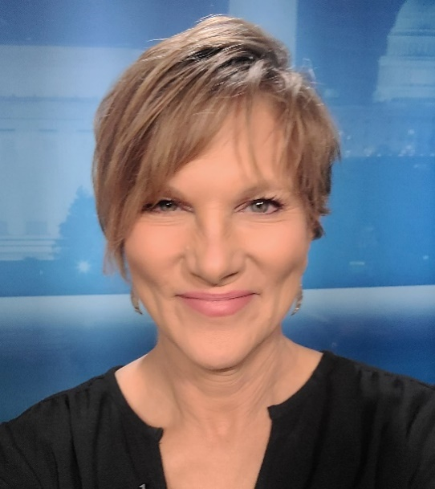

Caption: It’s Academic host Hillary Howard
Credit: Hillary Howard

