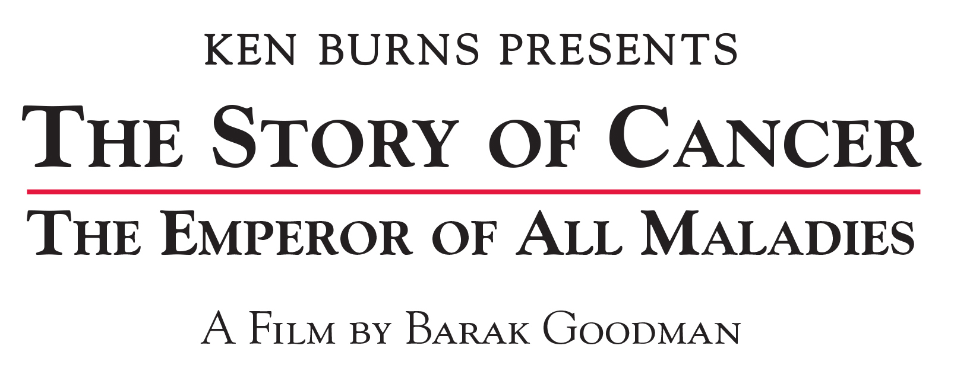

FLAGSHIP PBS STATION WETA LAUNCHES COMPANION WEBSITE
TO ken burns presents “The Story of Cancer:
The Emperor of All Maladies” A FILM BY BARAK GOODMAN

SPACE TO EXPLORE SCIENTIFIC, HISTORICAL AND PERSONAL
ASPECTS OF CANCER

Online Content, Part of National Outreach Initiative, to Supplement Documentary
Executive Produced by Ken Burns & Directed by Barak Goodman, Airing Spring 2015 on PBS

(Arlington, VA) — May 16, 2014 — Sharon Percy Rockefeller, the president and CEO of WETA, the Washington, D.C. public television station, today announced the launch of a new website that is part of the national outreach for Ken Burns Presents The Story of Cancer: The Emperor of All Maladies, a new documentary executive produced by Ken Burns. The six-hour film, airing on PBS in spring 2015, is based on the Pulitzer Prize-winning book The Emperor of All Maladies: A Biography of Cancer (Simon & Schuster 2010) by Siddhartha Mukherjee, M.D., and will be directed by the award-winning filmmaker Barak Goodman. This “biography” of cancer covers its first documented appearances thousands of years ago through the epic battles in the 20th century to cure, control and conquer cancer. The series matches the epic scale of cancer, reshaping the way the public sees cancer and stripping away some of the fear and misunderstanding that has long surrounded it.

The new website for The Story of Cancer — www.TheStoryofCancer.org — will be the first part of a comprehensive national outreach campaign. In an extraordinary collaboration the project outreach partners Stand Up To Cancer (SU2C), a program of the Entertainment Industry Foundation; the American Association for Cancer Research; and the American Cancer Society, along with project funders Genentech, Cancer Treatment Centers of America, Siemens, David H. Koch, Bristol-Myers Squibb, and the Kovler Fund, will utilize a wide-range of digital and grassroots platforms to engage people throughout the country around topics raised in the series, providing platforms for discussion surrounding cancer issues — the scientific, the historical and the personal — addressed in the series.

The website will be a place for a variety of groups — such as cancer survivors, patients, family and friends; caretakers, health care professionals and the research community; historians, educators and students — to understand the past, present and future of cancer in an interactive way.

The Story of Cancer website will feature exclusive digital short films showcasing cancer patients, caregivers, researchers and celebrity survivors. The first film, available on the website now, is a profile of cancer survivor Pamela Cromwell, a business analyst and cancer advocate who reveals how kickboxing transformed the way she fights the disease. WETA will release more than twenty additional films in the coming months through the Spring 2015 broadcast of The Story of Cancer. The digital short films, created by Redglass Pictures, will explore ideas and pose questions related to the documentary. The short films will spur dialogue months before The Story of Cancer airs, and will be linked through Twitter, discussed and shared on Facebook, and embedded in sites such as Gawker, under the project hashtag #CancerFilm.

The website will also feature a behind-the-scenes Producers’ blog, launching later this month, about the making of the documentary, with contributions from filmmaker Barak Goodman and executive producer Ken Burns and others. Building up to the broadcast premiere of the film in Spring 2015, new features will rollout on the website, including an interactive timeline, allowing users to explore the fight against cancer through video and other content that explains medical advances and profiles the people who have been instrumental in shaping the fight against cancer over time. Additionally, audiences will be able to contribute their own stories about cancer via an interactive story-sharing wall, creating one of the largest collections of cancer-related stories in the country. Live social media events will also showcase direct access to the filmmakers for moderated discussions about the subject matter and the art of filmmaking

Additionally, WETA will provide station grants to 50 local public broadcasting stations for significant community engagement projects to expand the reach of the series within their own markets. Stations will be well-equipped to extend engagement to their audiences with activities that will include screenings and panel discussions, local productions, social networking, and Web-based modules and multi-media exhibits.

Ken Burns Presents The Story of Cancer: The Emperor of All Maladies A Film by Barak Goodman is a production of Florentine Films, Laura Ziskin Pictures and WETA Washington, D.C., in association with Ark Media. Executive Producer and Series Creative Consultant: Ken Burns. Based on the book The Emperor of All Maladies: A Biography of Cancer by Siddhartha Mukherjee, M.D. Producer and Director: Barak Goodman. Executive Producers: Dalton Delan and David S. Thompson for WETA Washington, D.C.; and Pamela Oas Williams and Laura Ziskin for Laura Ziskin Pictures. Copyright: Laura Ziskin Pictures and WETA Washington, D.C. Outreach partners are Stand Up To Cancer (SU2C), a program of the Entertainment Industry Foundation; the American Association for Cancer Research; and the American Cancer Society. Funding for The Story of Cancer: The Emperor of All Maladies is provided by Genentech, Cancer Treatment Centers of America, Siemens, David H. Koch, Bristol-Myers Squibb, and the Kovler Fund.

# # #

About WETA Washington, D.C.
WETA Washington, D.C., is the second-largest producing station of new content for public television. WETA productions and co-productions include PBS NewsHour, Washington Week with Gwen Ifill, The Kennedy Center Mark Twain Prize, In Performance at the White House and documentaries by filmmaker Ken Burns, including the premiere this September of The Roosevelts: An Intimate History. More information on WETA and its programs and services is available at www.weta.org.

Press Contacts:

DKC Public Relations
Brian Moriarty (Brian_Moriarty@dkcnews.com)
Dan Roberti (Daniel_Roberti@dkcnews.com)
Sara Levin (Sara_Levin@dkcnews.com)
212.685.4300
#CancerFilm

