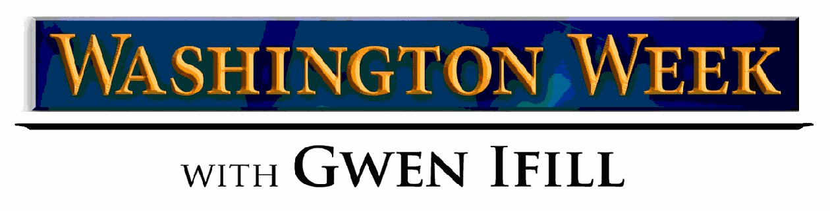

For Immediate Release
Press Contact: Susan Michels, WETA (703) 998-2440, smichels@weta.org

Washington Week with Gwen Ifill Launches New Fellowship Initiative for
2016 Election Cycle
Developing a New Generation of Journalism Excellence

Washington, D.C. – Taking advantage of the unique learning opportunity that the 2016 election cycle offers, Washington Week with Gwen Ifill, seen Fridays at 8:00 pm on PBS stations nationwide, today announced a new fellowship initiative to train emerging journalists, especially those from diverse backgrounds.

Funded by Newman’s Own Foundation, this six-month, paid, entry-level program will select four promising journalists over the next two year who are pursuing a career in TV news production, digital media, or reporting and provide them with an immersive experience.

“As I visit schools and campuses around the country, I've always been excited to meet the next generation of smart journalists,” said Gwen Ifill, moderator and managing editor of Washington Week. “With this new fellowship, Washington Week will now be able to expand our commitment to making sure we help nurture and groom young people who yearn to tell the news well, no matter the platform.”

Fellows will work with the Washington Week team to research national and international news stories, generate story ideas, produce broadcast and web content, and assist with the production of the weekly series and special online initiatives.

“We at Newman’s Own Foundation are honored to support the development of new leaders in journalism with Washington Week,” said Bob Forrester, president and CEO of the foundation. “Our hope is this fellowship will bring the public broadcasting system a pipeline of promising new talent as well.”

The fellowships will be available from:
- June through November 2015 (one fellow);
- December 2015 through May 2016 (one fellow); and
- June through November 2016 (two fellows).

A full job description is available at: http://www.weta.org/about/careers/jobs/washington-week-fellow.

Deadline for the first fellow applications is April 27, 2015.
A production of WETA Washington, D.C., Washington Week with Gwen Ifill is known for its depth, balance and civil discourse. For nearly 50 years, Washington Week has delivered the most interesting conversation of the week. It is the longest-running primetime news & public affairs program on television and was recognized for its journalism excellence with a 2009 Peabody Award. The senior producer is Chris Guarino. Executive producers are Jeff Bieber and Dalton Delan. The producer is Alla Lora. Matt Loffman is the multi-platform producer.
Gwen Ifill serves on the board of the News Literacy Project, an innovative national educational program that mobilizes seasoned journalists to work with educators to teach students how to sort fact from fiction. She is also a member of the Advisory Board for the Committee to Protect Journalists, an independent, nonprofit organization that promotes press freedom worldwide.
In addition to Newman’s Own Foundation, major funding for Washington Week with Gwen Ifill is provided by Prudential Financial, Boeing, The International Brotherhood of Electrical Workers (IBEW), The Annenberg Foundation, the Corporation for Public Broadcasting and PBS.
WETA is one of the largest-producing stations of new content for public television and serves Virginia, Maryland and the District of Columbia with educational initiatives and with high-quality programming on four digital television channels. Other WETA productions and co-productions include PBS NewsHour, The Kennedy Center Mark Twain Prize and documentaries by filmmaker Ken Burns, including the upcoming Ken Burns Presents Cancer: The Emperor of All Maladies A Film by Barak Goodman, airing March 30 - April 1, 2015. More information on WETA and its programs and services is available at weta.org.

Newman’s Own Foundation is an independent, private foundation formed in 2005 by Paul Newman to sustain the legacy of his philanthropic work. Funded entirely through the profits and royalties of Newman’s Own products, the Foundation does not maintain an endowment, raise funds, or accept donations. The Foundation believes that each of us, through the power of philanthropy, has the potential to make a difference. Since 1982, when Paul Newman first declared, “Let’s give it all away,” more than $400 million has been donated to thousands of nonprofit organizations helping people in need around the world.
###

